

**Nurse Hiring System Project Report**

**Assignment 1-2 – Software Requirement Specification**

**Team 1 – SE1435 – SWR301**

– Bac Kan, 27 June 2021 –

Table of Contents

I. Project Report 3

1. Status Report 3

2. Team Involvements 3

3. Issues/Suggestions 3

II. Project Introduction 4

1. Overview 4

1.1 Project Information 4

1.2 Project Team 4

2. Product Background 4

III. Software Requirement Specification 5

1. Overall Description 5

1.1 Product Overview 5

1.2 Business Rules 5

2. User Requirements 6

2.1 Overview 6

2.2 <<Feature Name 1 – User Functions>> 6

2.3 <<Feature name 2 – Manager Functions>> 8

3. Functional Requirements 10

3.1 System Functional Overview 10

3.2 All Fuctions 12

4. Non-Functional Requirements 14

4.1 External Interfaces 14

4.2 Quality Attributes 15

5. Other Requirements 16

5.1 Appendix - Messages List 16

# Project Report

## 1. Status Report

|  |  |  |  |
| --- | --- | --- | --- |
| **#** | **Work Item** | **Status** | **Notes (Work Item in Details)** |
| 1 |  | Pending |  |
| 2 |  | In Progress |  |
| 3 |  | Completed |  |

## 2. Team Involvements

|  |  |  |  |
| --- | --- | --- | --- |
| **#** | **Task** | **Member** | **Notes (Task Details, etc.)** |
| 1 | Front – End Develop | HaiLD |  |
| 2 | Back – End Develop | PhuongNL, ChienDC |  |
| 3 | Database Design, Function Design | DatHM,  PhuongNL |  |
| 4 | Business Analysts | TrungNH |  |
| 5 | Test, Debug Website | ChienDC |  |

## 3. Issues/Suggestions

|  |  |  |  |
| --- | --- | --- | --- |
| **#** | **Issue** | **Status** | **Notes (Solution, Suggestion, etc.)** |
| 1 |  |  |  |

# Project Introduction

## 1. Overview

### 1.1 Project Information

* Project name: Nurse Hiring System
* Project code: NHSK14
* Group name: SWR301-SE1435-T1
* Software type: Health Care Hybrid Application

### 1.2 Project Team

#### a. Supervisor

|  |  |  |  |
| --- | --- | --- | --- |
| **Full Name** | **Email** | **Phone Number** | **Title** |
| Pham Duc Thang | thangpd@fe.edu.vn |  | Lecturer |

#### b. Team Members

|  |  |  |  |
| --- | --- | --- | --- |
| **Full Name** | **Email** | **Mobile** | **Role** |
| Duong Cong Chien | chiendche141237@fpt.edu.vn |  | Leader |
| Luc Duong Hai | haildhe141223@fpt.edu.vn |  | Member |
| Nguyen Long Phuong | phuongnlhe141219@fpt.edu.vn |  | Member |
| Ha Manh Dat | dathmhe141249@fpt.edu.vn |  | Member |
| Nguyen Huu Trung | trungnhhe141239@fpt.edu.vn |  | Vice Leader |

## 2. Product Background

A majority of almost people in Viet Nam spent much time on works. And they spent 40 - 44 hours per week to works, so they don't have enough time for themself and their families. There were a lot of families because they didn't spend much time taking care of their parents then they have to bring their parents to a hospital and nursing home. This problem breaks down their relationships and stresses full while working.

Cause we care about these issues, so we provide a Nurse Ordering System. This system would save those employees specified time, this would improve both their quality of work-life and their productivity and also help them take care of their families at home.

Then, our system provides three best things: best services, best nurse, and a nurse come from the best hospital and center. Our system allows the customer to use services everywhere also at home.

* Allows users to register from their homes via a web browser.
* When user signup account, they will have their own favorite page to store musics.

# III. Software Requirement Specification

## 1. Overall Description

### 1.1 Product Overview

Our products make it possible for customers to connect faster with hospitals to order nurses, save time and have the best services. You can hire the best, most experienced nurses from the hospitals you trust most in your area.

### 1.2 Business Rules

|  |  |
| --- | --- |
| *ID* | *Rule Definition* |
| BR-01 | Account’s Facebook, Google address must valid |
| BR-02 | User must update phone number |
| BR-03 | User must update correct address and district level address. |
| BR-04 | User must update the bank number |
| BR-05 | User must provide informations of patient |
| BR-06 | Nurse must phone number |
| BR-07 | Nurse must allow system provide information of experience |
| BR-08 | Nurse Manger must response request order of nurse on office hours |
| BR-09 | Network transmissions involving financial or personally identifiable information require 256-bit encryption, bcrypt, md5. |
| BR-10 | Nurse must work enough time when user’s order |
| BR-11 | System confirms nurse plan after nurse finishes work. |
| BR-12 | User cannot order nurse while nurses were hired |
| BR-13 | System allow user to cancel order in 5 minutes, after hired nurse. |
| BE-14 | User can order more than one nurses |

## 2. User Requirements

### 2.1 Overview

#### a. Use Case Diagram

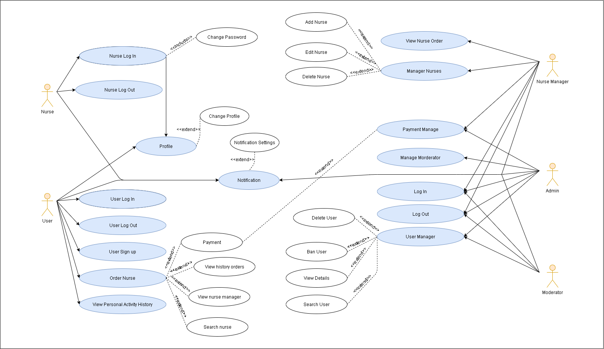

**Fig. 1. Use Case Diagram**

#### b. Use Case Diagram

|  |  |  |
| --- | --- | --- |
| Actor | Inherits Form | Description |
| User |  | Normal user or everyone who sign up an account |
| Nurse | Nurse Manager | Nurses in a group have manager by Nurse Manager |
| Nurse Manager |  | The Place provides nurses like Hospital or Heal Care Center |
| Admin |  | Administrator is staff, has a highest permission level and is responsible to management users |
| Moderator |  | Moderator is a group have manager by Admin, who helps admin manager system |

|  |  |  |  |
| --- | --- | --- | --- |
| ID | Actor | Name | Description |
| UC-01 | Nurse, User, Nurse Manager, Admin, Moderator | Log in | Log in to the Nurse Hiring System with normal account, Google, Facebook’s Account |
| UC-02 | Nurse, User, Nurse Manager, Admin, Moderator | Log out | Log out to the Nurse Hiring System |
| UC-03 | User | Sign up | User sign up a normal account or using Google, Facebook. |
| UC-04 | User, Nurse, Nurse Manager | Update Profile | Update their personal profile |
| UC-05 | User, Nurse, Nurse Manager, Admin, Moderator | View Profile | View personal profile.  1. User view nurse, nurse manager profile.  2. Admin view all infor profile  3. Moderator view nurse, user, nurse manager profile |
| UC-06 | User | Create Order Nurse | User create nurse orders |
| UC-07 | User | Delete Order Nurse | User delete nurse orders after hired nurse (BR-13) |
| UC-08 | User | View History Nurse Order | User view history nurse order |
| UC-09 | User | View User Manager | User view user manager infor like Hospital, Healcare center information |
| UC-10 | User | Search Nurse | User search name nurse to find what nurse they really want |
| UC-11 | User | Payment | When user paid money for system application |
| UC-12 | User, Nurse, Mod, Admin, Nurse Manger | Notifications | Notifications was show when all object person active their activities depends on their roles |
| UC-13 | Nurse Manager, Admin | View Nurse Order | Nurse manager view nurse order was created by user |
| UC-14 | Nurse Manager | Manage Nurse | System allows Nurse Manager:  1. Edit Nurse  2. Delete Nurse |
| UC-15 | Admin | Manage Moderator | System allows Admin add new Moderator |
| UC-16 | Admin | User Manager | System allows Admin to manage  1. Delete User  2. Ban User  3. View Detail Profile User  4. Search User |

### 2.2 <<Feature Name 1 – User Functions>>

#### a. <<Use Case Name 1.1 – Login System>>

|  |  |  |  |
| --- | --- | --- | --- |
| UC ID and Name: | UC – 01 Login | | |
| Created By: | Luc Duong Hai | Date Created: | 20/06/2021 |
| Primary Actor: | User, Admin | Secondary Actors: | Manager System |
| Trigger: | Member (User) and admin want to log in in system | | |
| Description: | On our website, if users and admin want to use website features, they have to log in with their account. If their account already exists, the system will display their role's own websites. If not, the system brings back the index page.  If you log in with the wrong accounts, the system will send notices. | | |
| Preconditions: | 1. User must have an account. 2. User must enter correct username and passwords. | | |
| Post-conditions: | 1. NO | | |
| Normal Flow: | 1. User click login button 2. Website system send login form 3. User enter username and passwords 4. If user enter username and passwords correctly, enter homepage 5. If not. Send back to Index page and send notifications. | | |
|  |  | | |
| Priority: | High | | |
| Frequency of Use: | Approximately 50 users, an average of one usage per day. | | |
| Other Information: | 1. User can cancel login form, stop login while they enter username and pass words. | | |
| Assumptions: | 1. User can login and use their account for 60 minutes. | | |
| Business Rule | BR-01 | | |

#### b. <<Use Case Name 1.2 – Sign up System>>

|  |  |  |  |
| --- | --- | --- | --- |
| UC ID and Name: | UC – 02 Sign up | | |
| Created By: | Luc Duong Hai | Date Created: | 20/06/2021 |
| Primary Actor: | User | Secondary Actors: | Admin |
| Trigger: | Guest want to sign up an account | | |
| Description: | If guest want to use special features, they should sign up a member account. If guest sign up a exist account, systemwill send them back to index page and send notice that “account already existed”, if user repass enter in correct, system will do same thing and send notice that Repass input wrong. | | |
| Preconditions: | 1. User muset enter correct passwords and repasswords. 2. Account sign up must not exists. | | |
| Post-conditions: | 1. Account sign up will be store as new value in manager systemdatabase. | | |
| Normal Flow: | 1. User click login button 2. Website systemsend login form. 3. Near login page, website have sign up part. 4. User click sign up part. 5. User enter username, passwords, repasswords. 6. If passwords and repass enter incorrect, send user to index page and send notice. | | |
| Priority: | Medium | | |
| Frequency of Use: | Approximately 50 users, an average of one usage per day. | | |
| Other Information: | 1. User can cancel sign up form, stop login while they enter username and pass words. | | |
| Assumptions: | NO | | |
| Business Rule | BR-01 | | |

#### c. <<Use Case Name 1.3 – Profile System>>

|  |  |  |  |
| --- | --- | --- | --- |
| UC ID and Name: | UC – 03 Profile | | |
| Created By: | Duong Cong Chien | Date Created: | 20/06/2021 |
| Primary Actor: | User, Admin | Secondary Actors: |  |
| Trigger: | Profile manager | | |
| Description: | When user enter Profile page, system show information of user and user can edit. | | |
| Preconditions: | 1. User must enter Profile page | | |
| Post-conditions: | 1. NO | | |
| Normal Flow: | 1. User enter Profile page. 2. System display profile of user 3. User click to edit to edit information 4. Click save to change | | |
| Priority: | Medium | | |
| Frequency of Use: | User can see profile when they create account and sign in to system | | |
| Other Information: | 1. none | | |
| Business Rule | BR-01, BR-02, BR-03, BR-04, BR-05 | | |

#### d. <<Use Case Name 1.4 – Hiring Nurse System>>

|  |  |  |  |
| --- | --- | --- | --- |
| UC ID and Name: | UC – 04 Hiring Nurse | | |
| Created By: | Nguyen Huu Trung | Date Created: | 27/06/2021 |
| Primary Actor: | User | Secondary Actors: | Admin |
| Trigger: | User want to Hiring Nurse | | |
| Description: | When a user enters the Hiring page, the user wants to search information and hire nurse | | |
| Preconditions: | 1. User login 2. User enter Hiring page | | |
| Post-conditions: | 1. Search value store in the database, after found result send back to the user. 2. Add contact information of user to database | | |
| Normal Flow: | 1. User enter Hiring page 2. User want to search information and choose nurse to hire 3. User confirm contact information 4. User confirm invoice | | |
| Priority: | High | | |
| Frequency of Use: | User can search value more than one.  When user hire nurse | | |
| Other Information: | 1. Value search will appear on the search bar. 2. Save contact information of user | | |
| Business Rule | BR-01, BR-05, BR-12, BR-13, BR-14, BR-06, BR-07, BR-08 | | |

#### e. <<Use Case Name 1.5 – View history activity of User >>

|  |  |  |  |
| --- | --- | --- | --- |
| ID and Name: | UC-05 View history activity of User | | |
| Created By: | Ha Manh Dat | Date Created: | 27/06/2021 |
| Primary Actor: | User | Secondary Actors: | Manager |
| Description: | User want to view the activity history of hiring | | |
| Trigger: | When member login their account, they can view and see their history | | |
| Preconditions: | 1. User must be Login | | |
| Postconditions: | Search History store in database, user can delete | | |
| Normal Flow: | 1. Member login enter History page. 2. Member view History activity 3. Member can delete | | |
| Alternative Flows: | None | | |
| Priority: | Medium | | |
| Frequency of Use: | None | | |

#### f. <<Use Case Name 1.6 – Notification >>

|  |  |  |  |
| --- | --- | --- | --- |
| UC ID and Name: | UC – 06 Notification | | |
| Created By: | Nguyen Long Phuong | Date Created: | 27/06/2021 |
| Primary Actor: | Admin, user | Secondary Actors: | Manager System |
| Trigger: | System show the status of hiring | | |
| Description: | In our website user can see the status of hiring | | |
| Preconditions: | 1. User must Login | | |
| Post-conditions: | 1. Show status store in database | | |
| Normal Flow: | 1. Admin login with the supplied account. 2. System send message for user | | |
| Priority: | medium | | |
| Frequency of Use: | None | | |

#### g. <<Use Case Name 1.7 – View Nurse order >>

|  |  |  |  |
| --- | --- | --- | --- |
| UC ID and Name: | UC – 06 View | | |
| Created By: | Ha Manh Dat | Date Created: | 27/06/2021 |
| Primary Actor: | Nurse(user) | Secondary Actors: | Manager |
| Trigger: | System show the hiring detail | | |
| Description: | In our website user can see hiring detail | | |
| Preconditions: | 1. User must Login | | |
| Post-conditions: | 1. Show nurse order store in database | | |
| Normal Flow: | 1. Must login with the supplied account. 2. System view the order detail | | |
| Priority: | medium | | |
| Frequency of Use: | None | | |

#### h. <<Use Case Name 1.8 – Search Nurse >>

|  |  |  |  |
| --- | --- | --- | --- |
| UC ID and Name: | UC – 06 Search Nurse | | |
| Created By: | Duong Cong Chien | Date Created: | 27/06/2021 |
| Primary Actor: | Nurse(user) | Secondary Actors: | Manager |
| Trigger: | User want to search information nurse | | |
| Description: | When a user enters the home page, the user wants to search information of nurses | | |
| Preconditions: | 1. User must Login | | |
| Post-conditions: | 1. Show nurse order store in database | | |
| Normal Flow: | 1. User enter home page  2. User want to search Information of nurse  3. If the user enters none exist infor of Nurse, the system will send a blank page  4. If infor of Nurse already existed, the system will show it on screen | | |
| Priority: | medium | | |
| Frequency of Use: | None | | |

### 2.3 <<Feature name 2 – Manager Functions>>

#### a. <<Use Case Name 2.1 – Nurse manager >>

|  |  |  |  |
| --- | --- | --- | --- |
| ID and Name: | UC-05 View history activity of User | | |
| Created By: | Duong Cong Chien | Date Created: | 27/06/2021 |
| Primary Actor: | Admin | Secondary Actors: | Manager |
| Description: | Admin manage information of nurse | | |
| Trigger: | When admin login their account, they can view nurse and to allocate jobs  Admin can edit/remove/add User | | |
| Preconditions: | Admin must be Login | | |
| Postconditions: | View Nurse store in database, admin allocate jobs of nurse and add in database | | |
| Normal Flow: | 1. Admin login enter Nurse management page.  2. Admin can view nurse information, delete, and arrange works for nurse | | |
| Alternative Flows: | None | | |
| Priority: | High | | |
| Frequency of Use: | None | | |

#### b. <<Use Case Name 2.2 – Payment Manager >>

|  |  |  |  |
| --- | --- | --- | --- |
| ID and Name: | UC-05 View history activity of User | | |
| Created By: | Ha Manh Dat | Date Created: | 27/06/2021 |
| Primary Actor: | Users | Secondary Actors: | Manager |
| Description: | Users make payment for the service | | |
| Trigger: | When user login their accounts, they order nurses, make payment through credit card | | |
| Preconditions: | User must be Login | | |
| Postconditions: | Users make payment through credit card the money will be transferred to the hospital bank account | | |
| Normal Flow: | 1. User must login and order nurse.  2. users make payment for the services | | |
| Alternative Flows: | None | | |
| Priority: | High | | |
| Frequency of Use: | None | | |

#### c. <<Use Case Name 2.3 – User manager >>

|  |  |  |  |
| --- | --- | --- | --- |
| UC ID and Name: | UC – 06 User manager | | |
| Created By: | Luc Duong Hai | Date Created: | 27/06/2021 |
| Primary Actor: | Admin | Secondary Actors: |  |
| Trigger: | Admin want to edit/remove/add User | | |
| Description: | In our website admin can edit/remove/add User | | |
| Preconditions: | 1. User must have admin roles.  2. Song edit/add must not exist and not similar to others. | | |
| Post-conditions: | 1. Check users. After that send data for admin management.  2. Admin adds the users and stores them in the database. | | |
| Normal Flow: | 1. Admin login with the supplied account.  2. Admin enter manage page.  3. Admin chooses which options they want to manage.  4. If the admin chooses user management, the system sends the admin to the user management page, allow the admin to add/edit/remove the user.  5. If the admin adds user, the system will check exists account and similar account. If user do not exists add new ones. Like add, edit functions let admin edit user which was existed in the database. | | |
| Priority: | High | | |
| Frequency of Use: | None | | |

## 3. Non-Functional Requirements

### 3.1 Quality Attributes

#### a. Usability

The system can be easy to use, the system will provide the best conditions for users to perform tasks, the function of the website safely, efficiently. User gets nurse and hiring with high-quality service.

#### b. Reliability

* Availability: The system can work stable in almost time when user access. About 70% of user satisfied with nurse order and quality of service, only admin has permission to maintain the website.
* Mean Time Between Failures (MTBF): About 3-5 minutes.
* Mean Time to Repair (MTTR): About 30-60 minutes.
* Accuracy: About 80%.
* Maximum Bugs or Defect Rate: About 5%
* Bugs or Defect Rate: About 5%

#### c. Performance

For better performance, the application will allow a maximum of 50 user access at the times, and a stable network.

#### d. Dependability

Depend on a local server, depend to copy right issue and policy terms of service.

#### e. Supportability

Modifiability is minimal, might allow the user to edit data in the database but not allow to edit code.

#### f. Design Constraints

This section we using to design the website was photoshop, figma, to code we using Visual Studio 12 with C#, .Net Core, NodeJS, ReactJS, HTML, CSS, JS, API.

#### g. Support Documents

Using a Facebook plugin to make Facebook comments.

Using facebook api, google api allows user login.

Using c#, NodeJS, ReactJS tutorial docs, bootstraps, and other heal care support websites.

#### h. Purchased Components

None

## 4. Entity Relationship Diagram

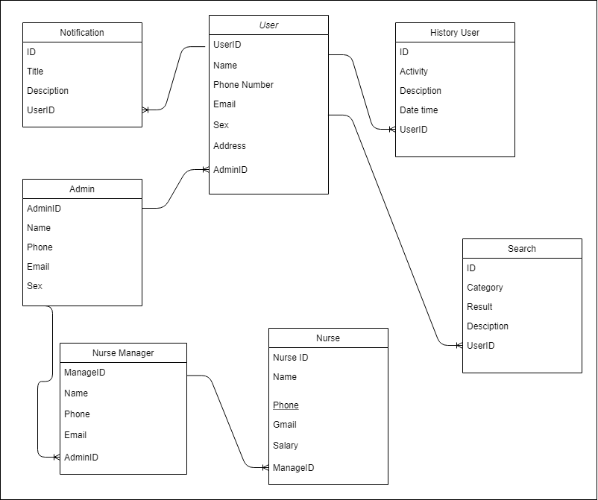***Fig. 2. Entity Relationship Diagram***